**Good Extracts**

**Project Plan**

Prepared By: Jae Doyne

March 2021

# Overview – Problem to Solve

This document is a plan to build a web application that primarily enables users to barter for and share goods and services within their local community over the internet.

The app seeks to:

* Increase:
  + Recycling of existing goods
  + Sharing of existing goods
  + Upcycling of existing goods,
  + Production of new goods from the home,
  + Composting items
  + Reduction of needed items
  + Refusal of unneeded items
  + Understanding of sustainable living practices

In an effort to:

* reduce transit distance between good exchanges
* reduce carbon emissions and environment concerns associated with manufacturing new items and disposing of used items
* Filling and upskilling local service gaps,
* Increasing individual sustainability practices,
* Increasing community connectivity and,
* Providing people with a means to increase their productivity and sense of purpose.

The following key pain points have been identified as relevant to many people today.

1. People feel disconnected from others/their community, and crave interaction/connection to a particular group or ‘tribe’
2. People are concerned about the environment and capital consumption, and want to reduce their carbon footprint and pursuit of materialism
3. People have ‘things’ lying around their houses that they don’t need or use that could be swapped for something else or given away freely
4. People lack avenues to increase their purpose/sense of use and would relish the opportunity to contribute more meaningfully
5. People are interested in pursuing ‘mini-entrepreneurship’ from their homes and increasing the productivity of their home and land, and sharing this with the community

# Key Goals for the Project

What I aim to achieve by completing this project:

* **Complex web app that can be shown to prospective employers.**

I want the web app to demonstrate:

* Good use of HTML, CSS and JavaScript
* Base knowledge of React components
* Connected MySQL database, with good database design (3NF)
* Use of an Express NodeJS server with RESTful end points, authentication, validation, segregation of views and data, database control
* Use of MVC architecture
* Clean and well written code with commenting
* Understanding of running tests and debugging
* Using Git and Jira
* Updating the READ.ME

Implementation Roadmap

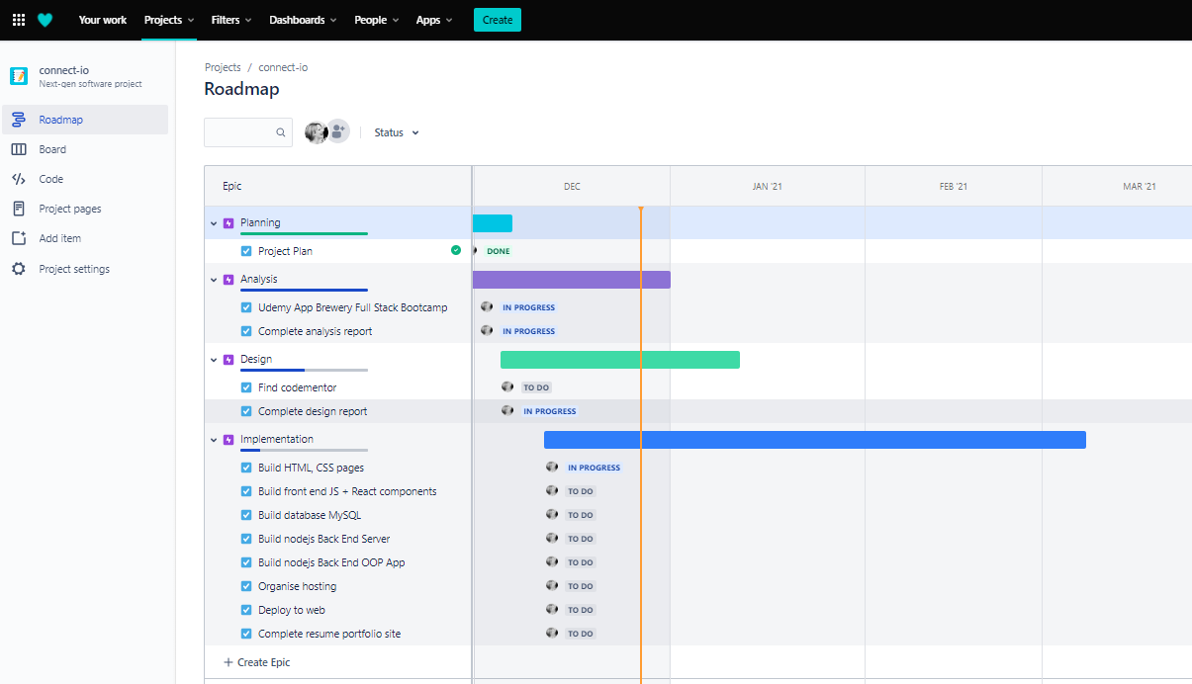

# Market Research

Also – what do they do wrong? What do they do right?

<https://www.streetbank.com/funding?locale=en>

* Freecycle
* Etsy
* <https://swapmeet.net.au/>
* <https://www.sellbuyswap.com.au/>
* Facebook marketplace
* Gumtree swap
* Craigslist

<https://www.savethestudent.org/shopping/top-five-swapping-websites.html>

<https://www.choice.com.au/shopping/online-shopping/selling-online/articles/online-sharing-platforms>

<https://communityexchange.net.au/terms.asp?xid=wwll>

<https://www.timebanking.com.au/> - services swap

https://au.ziilch.com/

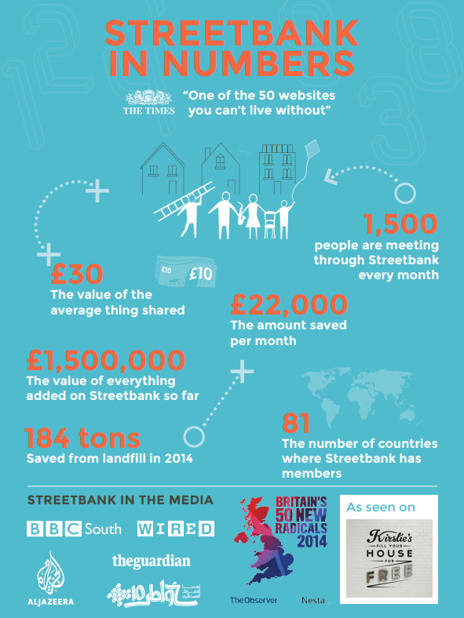

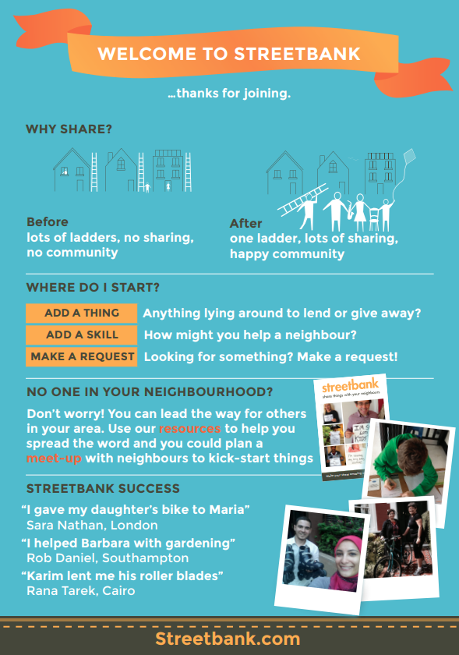

# Target Market, Story, Voice

The ideal user is:

* Socially and environmentally conscious, cultivating compassion and gratitude, connecting with community
* Interested in permaculture, upcycling household items, circular economics
* Looking to upskill, industrious, improve household productivity
* Retirees looking to help out, younger volunteers

Feelings to Inspire

* Turn yourself or your family unit into a business
* Reconnect with your community
* Feel good by helping others
* Feel good by recycling items rather than buying new
* Feel good by acquiring items locally rather than from afar
* Feel good by improving your productivity, skill set
* Feel good by feeling useful
* Reduce your carbon footprint
* Feel like you are part of a local ‘tribe’
* Demonstrate and gain recognition for your individuality from your community
* Feel safe and secure
* Not about ‘swapping stuff’, but about creating and developing a persona and hub of useful activity/production that benefits you and your community
* Focus has to be on the user/user’s family and community, not on the stuff
* Make it safe to use and exchange goods + services
* Don’t want to be seen as just shifting around crappy stuff
* Make it welcoming and not judgmental